Ahel

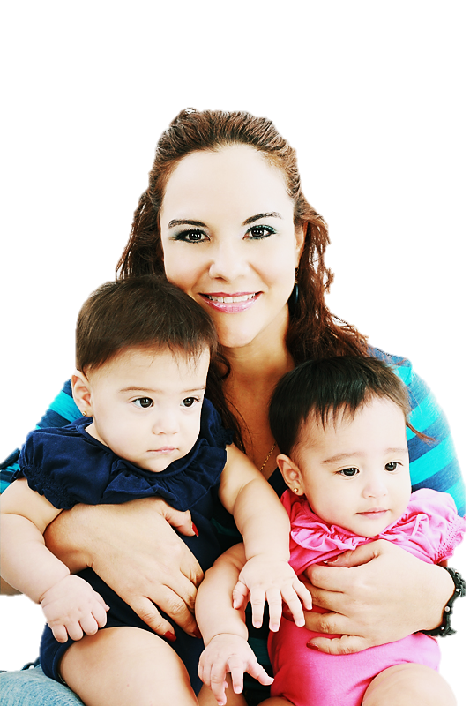



Learn more about Welcome Baby at

[hospital name]:

[phone number]



[add logo here]

